**LAYOUT - FORMAT**

**Title** - Heading on our page

**Post Content Rows** (Widgets) “Callouts” in BigTree language

**Card Rows** - groups of 3-4 cards

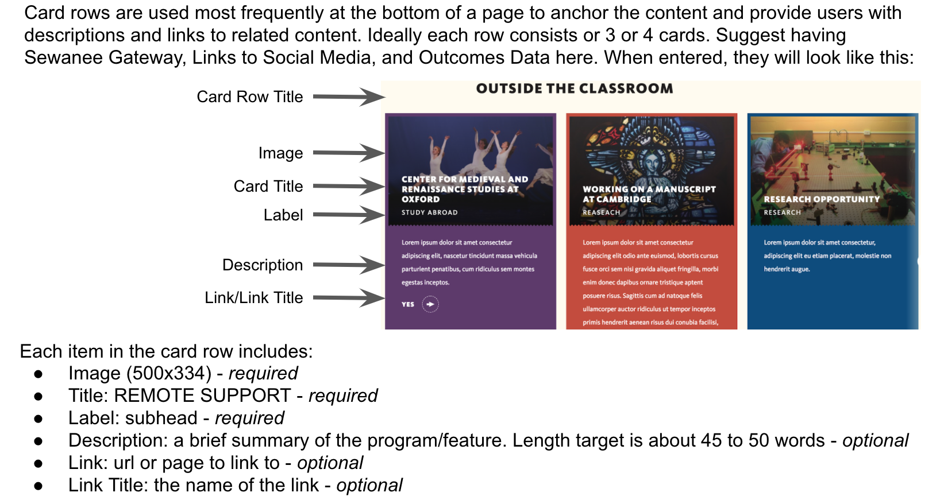

**Facts -** Infographic, 3 colorful “flags” on website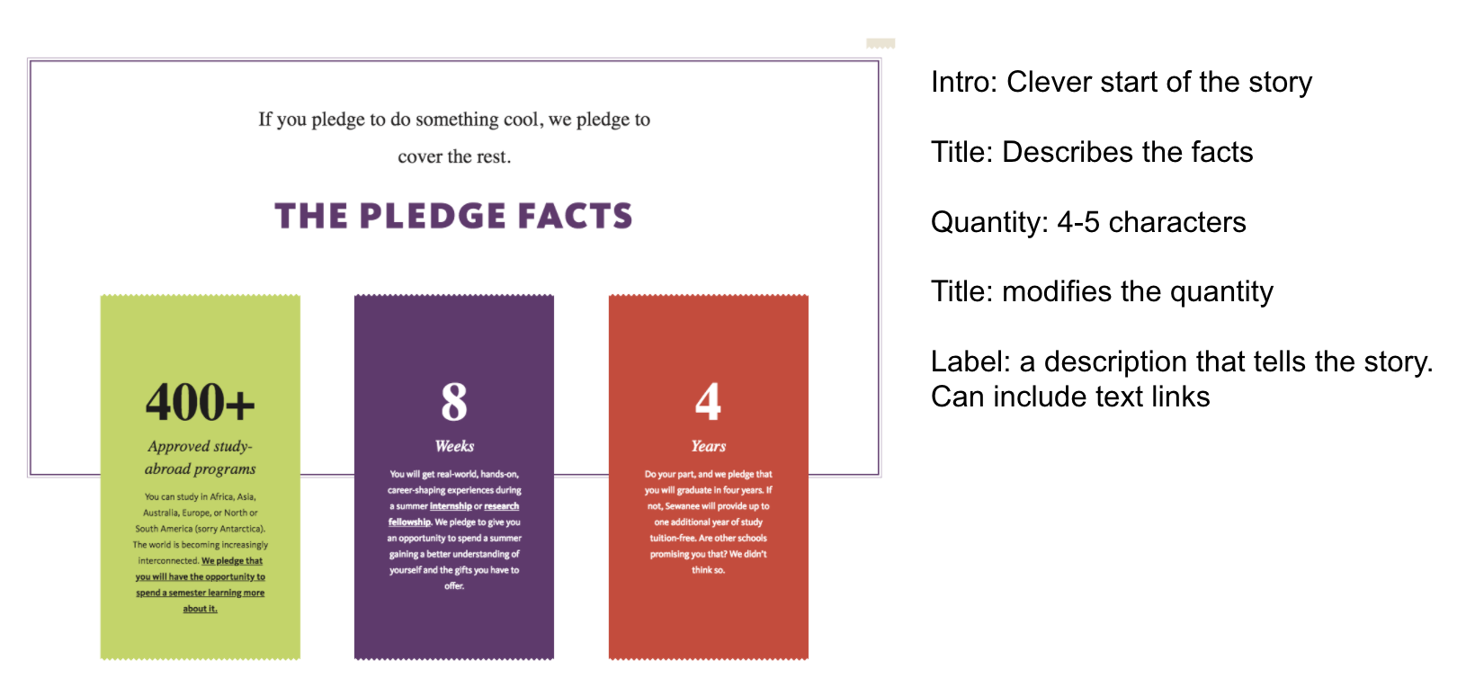

**Topic Row** - Introduction to related info on a page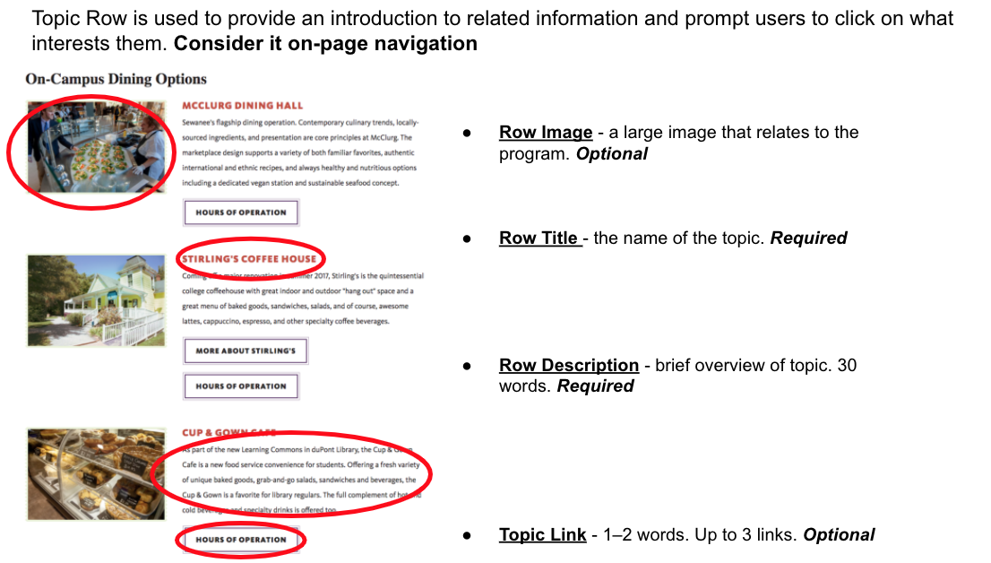

**Story**

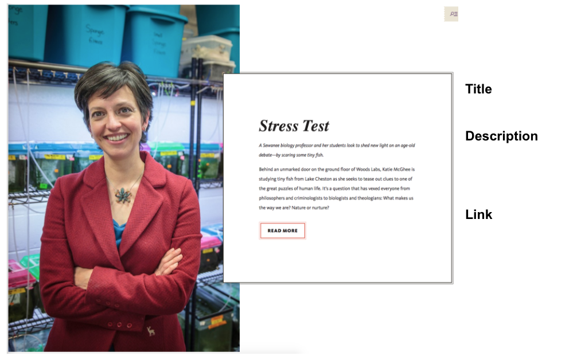

**Video Profile** - Allows you to merchandise a great image with a clever headline and intro copy.

**WYSIWYG** - Utility widget that can be used for a number of content purposes

**Supporting Tasks - Images**: a place to hold all of our images for use on website

**Supporting Tasks - Files**: a place to hold any pdf or documents to link to on our website

____________________________________________________________

Site Map

url: new.sewanee.edu/career-center (currently)

new.sewanee.edu/careers ?

(Landing Page) Career Center (include photo?)

(intro, purple paragraph text - landing page) use mission/vision?

(Video Profile? - landing page) Add later?

(story, requires image - landing page) Remote Support

(facts - landing page)

(topic row - landing page) No matter where you are in your career exploration and decision-making, Sewanee Career Center can help.

(Story, requires image - landing page) Meet our staff

(Card Rows - landing page)

(WYSIWYG - other)

(WYSIWYG - other) Social media footer

(WYSIWYG - other) Chat feature

(page) Remote Support (Resources/Toolbox)

(intro, purple paragraph - remote support) Career Center Remote Operation Plans

(post content text - remote support) Summer Virtual Appointments Are Available!

(topic row - remote) Overview of Resources

(Card Rows - remote)

(WYSIWYG - other) Contact Us - social media footer

(WYSIWYG - other) Chat feature

(page) Events

(story - events) Beyond The Gates Signature Event

(topic row - events) Other Signature Events

(topic row - events) Virtual Events

(WYSIWYG - other) Contact Us - social media footer

(WYSIWYG - other) Chat feature

(page) Beyond The Gates

(post content text)

(topic row) BTG keynote speakers

(WYSIWYG - other) Contact Us - social media footer

(WYSIWYG - other) Chat feature

(Page) Early Student Engagement

(topic row - Early Student Engagement) Overview

(Card Rows - Early Student Engagement)

(WYSIWYG - other) Contact Us - social media footer

(WYSIWYG - other) Chat feature

(page) Get to Know The Career Center Staff

(intro - purple paragraph)

(Topic Row - staff) Meet our staff

(post content - staff) Need Help?

(Topic Row - staff)

(Card Rows - get to know us, require images)

(WYSIWYG - other) Contact Us - social media footer

(WYSIWYG - other) Chat feature

(page) Internships

(intro text, purple paragraph - internships)

(facts - internships)

(post content - internships) Internships

(intro text - purple paragraph) Need help?

(topic row - internships) Employers & Recruiters

(card rows - internships)

(WYSIWYG - other) Contact Us - social media footer

(WYSIWYG - other) Chat feature

(page) Engage with/support Sewanee students

(intro, purple paragraph - our students) Get to know Sewanee students

(topic row - our students) You can help Sewanee students when you:

(facts - our students)

(card rows - our students)

(WYSIWYG - other) Contact Us - social media footer

(WYSIWYG - other) Chat feature

(page) Career Competencies

(post content text - competencies)

(topic row without buttons - competencies) Develop Career Competencies

(card rows, require images - competencies)

(WYSIWYG - other) Contact Us - social media footer

(WYSIWYG - other) Chat feature

## (Landing Page) Career Center (include photo?)

### (intro, purple paragraph text - landing page) use mission/vision?

(text) We help students discover their strengths, explore potential majors, explore careers and pursue specific internships and jobs, learn career skills through workshops, individual appointments and other opportunities, gain real-world job experience through our strong internship program, connect with the extensive Sewanee network of alumni and parents and discover the tools needed to apply to graduate or professional school.

### (Video Profile? - landing page) Add later?

Intro to our office staff and what we offer (Kim or all of us could do a few minutes each about what our roles are?)

### (story, requires image - landing page) Remote Support

(title) Remote Support

(text) The Career Center staff thrives on connection with and support of our students, and we intend to provide support while our community works remotely. We look forward to the day we can be together again; until then, here are the ways we will support you. Please let us know if you think of additional ways we can provide support by writing careers@sewanee.edu.

(button) Read more (link to remote support page)

### (facts - landing page)

(title)

(text - Awards)

(text - Internships)

(text - First Destination)

### (topic row or content post, no photos needed - landing page) No matter where you are in your career exploration and decision-making, Sewanee Career Center can help.

(title) Meet with us one-on-one

(text) We work with students who are focused and need specific assistance with cover letters and resumes, networking and job search advice, or preparing for an interview. Likewise, we work with students who feel overwhelmed and confused by the process of choosing a major, first job or internship or even what step to take next.

(button) Schedule an appointment (handshake)

(button) Email us ([careers@sewanee.edu](mailto:careers@sewanee.edu))

(button) Update your resume (vmock)

(title) The power of the Sewanee network

(text) Supported through our office and the Sewanee Alumni office, LinkedIn and Sewanee Gateway are robust tools for developing and nurturing a professional network. Connect with alumni and others you know, search for companies or industries of interest and prepare to be surprised at all of the amazing careers crafted by Sewanee alumni.

(button) Sewanee Gateway Alumni Directory

(button) LinkedIn for Alumni & Parents

(button) Career Center LinkedIn

(title) Engage with our office?

(text) Attend workshops, panels and other events hosted by the Career Center.

(button) Beyond the Gates (link to BTG page)

(button) Explore All Events (link to events page)

(button) Early Student Engagement (link to page)

(title) Discover opportunities

(text)

(button) Understand Career Competencies (link our page)

(button) Explore Internship Opportunities (link to internship page)

(button) Find Resources (Brightspace)

### (Story, requires image - landing page) Meet our staff

(title) Meet the Career Center Staff (use our group photo)

(text)

(button) Meet our staff (our staff page)

(button, can there be two buttons on a story?) Our office bio? ([PDF](http://careers.sewanee.edu/media/careers/SCC-services-sell-sheet_Nov19.pdf))

### (Card Rows - landing page)

* Sewanee Gateway
* Internships
* Career Competencies
* Majors & Minors

### (WYSIWYG - other)

* Outcomes data and majors/careers interactive infographic? <http://careers.sewanee.edu/toolbox/general-information/content/outcomes-infographic/>

### (WYSIWYG - other) Social media footer

* Icons: youtube, instagram, FB, LinkedIn, and Pinterest, twitter

### (WYSIWYG - other) Chat feature

## (page) Remote Support & Resources

(use resources in the url, but call it remote support and resources for now)

### (intro, purple paragraph - remote support) Career Center Remote Operation Plans

### (post content text - remote support) Summer Virtual Appointments Are Available!

(text) Students will continue to initiate virtual individual meetings with Career Center staff members via Handshake. (desktop or app) Appointments are conducted by Zoom (or Google Video Chat/Hangout, if needed). Please remember that Sewanee is in the central time zone.

When creating appointments, students will select which communication method they prefer. When scheduling your appointment, please select "video call" (preferred) or "phone call". Should Zoom experience technical difficulties during your appointment, please use the chat feature to problem solve with your Career Center staff member.

### (topic row - remote) Overview of Resources

(title) VMock

(text) An AI service for Sewanee students to get instant resume feedback.

(button) Login to VMock

(button) Samples

(title) Brightspace

(text) Resources only available to Sewanee Students

(button) Resumes & Cover Letters (directly to resource/folder?)

(button) Graduate School (directly to folder??)

(button) ?

(title) LinkedIn

(text)

(button) Setting up your LinkedIn profile (our resource?)

(button) LinkedIn for Alumni & Parents (group page)

(button) Career Center LinkedIn (new page)

(title) Sewanee Gateway

(text) Alumni Directory

(button) Sewanee Gateway

(button)

(title) Handshake

(text) The comprehensive online platform for jobs and internships.

(button) Make an Appointment

(button) Explore jobs

(button) Help Resources

(title) Career Insider by Vault

(text) This resource includes **insider information** for over 5000 companies and 70 industries, including salary surveys for major employers. It also includes information on top graduate and professional schools.

(button) [Take me there!](http://careerinsider.vault.com/wps/portal/careerinsider?parrefer=2203)

is an interactive tool for job seekers and students to learn more about their career options. (title) My Next Move

(text) View tasks, skills, salary information, and more for over 900 different careers.

(button) [My Next Move](http://www.mynextmove.org/)

### (Card Rows - remote)

* [Sewanee addresses Covid-19](https://new.sewanee.edu/2019-novel-coronavirus-covid-19/)
* Early Student Engagement (our page)
* Events (our page)
* Internships (our page)

### (WYSIWYG - other) Contact Us - social media footer

* Sewanee Career Center

43 Texas Ave Sewanee, TN 37375

(931) 598-1121 | careers@sewanee.edu

* Icons: [youtube](https://www.youtube.com/channel/UCkrLJFbi-dfB_hawOUNYmfw/featured), [instagram](https://www.instagram.com/sewanee_career/), [FB](https://www.facebook.com/SewaneeCareer/), LinkedIn, and Pinterest, [twitter](https://twitter.com/Sewanee_Career)

### (WYSIWYG - other) Chat feature

## (page) Events

### (story - events) Beyond The Gates Signature Event

(text) Juniors and seniors are invited to participate in a fast-paced and engaging weekend staffed by alumni and parents from a variety of career fields and areas of the country. The weekend includes networking opportunities, practice interviews, business dining etiquette, career-specific panel discussions, and advice on life and work after Sewanee.

(button) Learn more (link to Beyond the Gates page)

### (topic row - events) Other Signature Events

(title) Smith Career Day

(text) An abbreviated

(title) Out for Work

(text)

(title) Careers in Health and Medicine

(text)

(title) Preparing for Graduate School

(text)

(title) Graduate School Fair

(text)

(title) Summer Opportunities Fair

(text) After winter break, we host ranches, conference centers, camps and other summer employers to meet and share materials with Sewanee students on campus.

### (topic row - events) Virtual Events

(title) Upcoming Events

(button) View Brightspace Calendar

(button) View Events in Handshake

(title) Careers in Tech, Data, and Start-Ups Panel (May 1, 2020)

(button) [View Replay](https://www.youtube.com/watch?v=_Fqy0jhBF_8&list=PLoK_0itRgEYNU8WsweR2hovd3IscKH1i2&index=8&t=0s)

(title) Considering Graduate of Professional School Now? Panel (April 24, 2020)

(button) [View Replay](https://www.youtube.com/watch?v=lhHTJmUtywM&list=PLoK_0itRgEYNU8WsweR2hovd3IscKH1i2&index=7&t=3s)

(title) Cathy Carlisi on Purpose-Driven Leadership (April 22, 2020)

(button) [View Replay](https://www.youtube.com/watch?v=xS2LZfsfEag&t=25s)

(title) Graduating into a Troubled Economy Panel: 2008 & 2009 graduates share lessons from their early careers (April 17, 2020)

(button) [View Replay](https://www.youtube.com/watch?v=Kdt71AV6G68&list=PLoK_0itRgEYNU8WsweR2hovd3IscKH1i2&index=5&t=1s)

(title) Networking and Job Searches in a Pandemic Panel (April 3, 2020)

(button) [View Replay](https://youtu.be/Z8qtBnFOjhs)

(title) Sewanee Women in Business Panel (March 27, 2020)

(button) [View Replay](https://youtu.be/vsAD9pqWUZc)

### (WYSIWYG - other) Contact Us - social media footer

* Sewanee Career Center

43 Texas Ave Sewanee, TN 37375

(931) 598-1121 | careers@sewanee.edu

* Icons: [youtube](https://www.youtube.com/channel/UCkrLJFbi-dfB_hawOUNYmfw/featured), [instagram](https://www.instagram.com/sewanee_career/), [FB](https://www.facebook.com/SewaneeCareer/), LinkedIn, and Pinterest, [twitter](https://twitter.com/Sewanee_Career)

### (WYSIWYG - other) Chat feature

## (page) Beyond The Gates

<https://new.sewanee.edu/career-center/beyond-the-gates/>

### (post content text)

(text) Juniors and seniors are invited to participate in a fast-paced and engaging weekend staffed by alumni and parents from a variety of career fields and areas of the country. The weekend includes networking opportunities, practice interviews, business dining etiquette, career-specific panel discussions, and advice on life and work after Sewanee.

Students who participate in Beyond the Gates have the chance to network with helpful alumni and parents and to learn about

* various careers and career paths
* how to begin and conduct a job search
* helpful tips on interviewing and the opportunity for a practice interview
* resumes and cover letters with the opportunity for a critique
* what it's like to live and work in various cities from those who are there
* personal finance and budgeting
* business dining etiquette and networking techniques
* succeeding in the first year on the job

### (topic row) BTG keynote speakers

(title) 2018 -

(text)

(title) 2019 -

(title) 2020 - Kristen Morrissey Theide, C’98,

(text) CEO, First Step Project and SVP, Two Sigma (Prior: Google)

### (WYSIWYG - other) Contact Us - social media footer

* Sewanee Career Center

43 Texas Ave Sewanee, TN 37375

(931) 598-1121 | careers@sewanee.edu

* Icons: [youtube](https://www.youtube.com/channel/UCkrLJFbi-dfB_hawOUNYmfw/featured), [instagram](https://www.instagram.com/sewanee_career/), [FB](https://www.facebook.com/SewaneeCareer/), LinkedIn, and Pinterest, [twitter](https://twitter.com/Sewanee_Career)

### (WYSIWYG - other) Chat feature

### 

## (Page) Early Student Engagement

### (topic row - Early Student Engagement) Overview

(title)

(text)

(button)

(button)

(button)

(title)

(text)

(button)

(button)

(button)

(title)

(text)

(button)

(button)

(button)

### (Card Rows - Early Student Engagement)

* 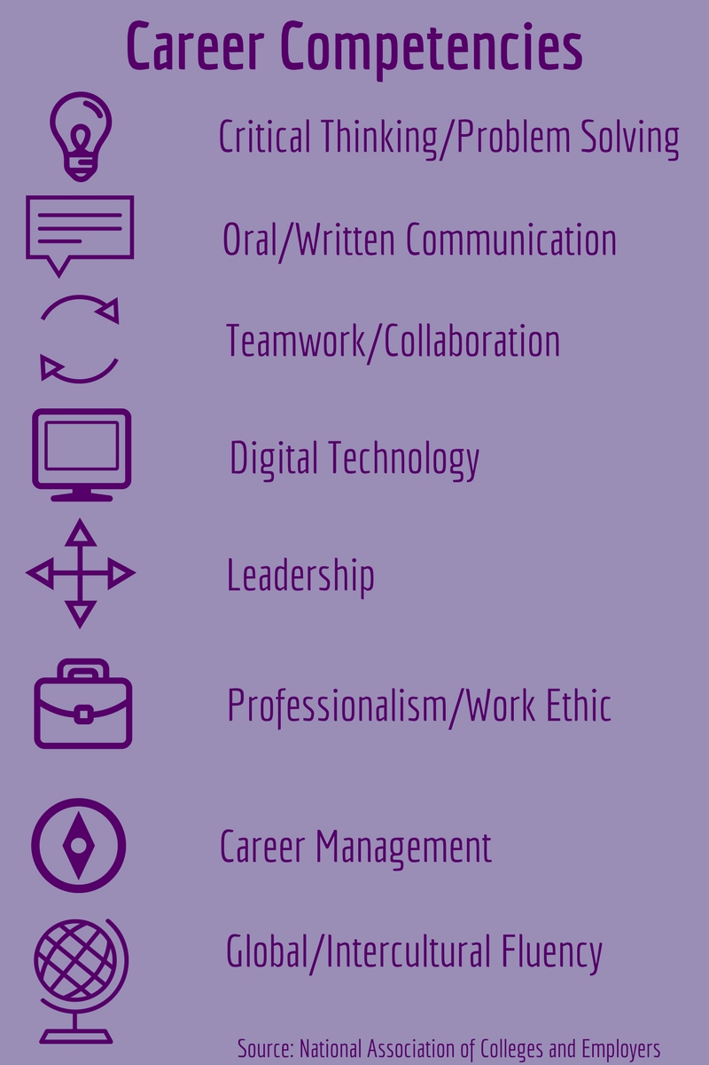Career Competencies (our page)
* Majors & Minors (university link)
* Events (our page)
* Other University office? (university link)

### (WYSIWYG - other) Contact Us - social media footer

* Sewanee Career Center

43 Texas Ave Sewanee, TN 37375

(931) 598-1121 | careers@sewanee.edu

* Icons: [youtube](https://www.youtube.com/channel/UCkrLJFbi-dfB_hawOUNYmfw/featured), [instagram](https://www.instagram.com/sewanee_career/), [FB](https://www.facebook.com/SewaneeCareer/), LinkedIn, and Pinterest, [twitter](https://twitter.com/Sewanee_Career)

### (WYSIWYG - other) Chat feature

### 

## (page) Get to Know The Career Center Staff

### (intro - purple paragraph)

(intro text) Career Center staff members coach and equip students and recent graduates for lives of achievement and service. We assist in this process by helping students connect their strengths, interests, and career-readiness skills with knowledge about careers as they prepare for purposeful work. We value connectedness, individualized support, reflection, relationships, and a welcoming environment.

(plain text) Sewanee is a member of the National Association of Colleges and Employers (NACE) and abides by the [principles for professional practice](https://www.naceweb.org/career-development/organizational-structure/principles-for-ethical-professional-practice/).

### (Topic Row - staff) Meet our staff

(title) Shanna Abramson

* + (paragraph text)
    - (button) Email Us (careers email)
    - (button) Resources (link to our page)
    - (button) What we offer ([PDF](https://www.sewanee.edu/media/careers/SCC-services-sell-sheet_Nov19.pdf))

(title) Rachel Fredericks

* + (paragraph text)
    - (button) Schedule an Appt (link to sewanee.joinHandshake.com),
    - (button) Linkedin bio,
    - (button) Early Student Engagement?

(title) Kim Heitzenrater

* + (paragraph text)
    - (button) Schedule an Appt (link to sewanee.joinHandshake.com),
    - (button) Linkedin bio,
    - (button) ?

(title) Kate Reed

* + (paragraph text)
    - (button) Schedule an Appt (sewanee.joinHandshake.com),
    - (button) Linkedin bio,
    - (button) ?

(title) Melissa Webb

* + (paragraph text)
    - (button) Schedule an Appt (sewanee.joinHandshake.com),
    - (button) Linkedin bio,
    - (button) Internships?

(title) Sallie Williams

* + (paragraph text)
    - (button) Linkedin bio,
    - (button) Email me,
    - (button) For employers?

### (post content - staff) Need Help?

(text) Need help? We are ready to offer our assistance to you every step of the way! Many opportunities are available to get the help you need. Make an appointment with a Career Center advisor through [Handshake](https://sewanee.joinhandshake.com/login) or email us at [careers@sewanee.edu](mailto:careers@sewanee.edu). We are available remotely by appointment only Monday-Friday from 8 a.m. to Noon and 1-4:30 p.m.

### (Topic Row - staff)

(title) Need help? We are ready to offer our assistance to you every step of the way!

(button) Make a virtual appointment ([Handshake](https://sewanee.joinhandshake.com/login))

(button) Email us ([careers@sewanee.edu](mailto:careers@sewanee.edu))

(button) Check out our Resources (Brightspace resources?)

### (Card Rows - get to know us, require images)

* Remote Support
* Outcomes Data (PDF?) not sure this is the right medium for this
* Career Competencies (page)
* ?

### (WYSIWYG - other) Contact Us - social media footer

* Sewanee Career Center

43 Texas Ave Sewanee, TN 37375

(931) 598-1121 | careers@sewanee.edu

* Icons: youtube, instagram, FB, LinkedIn, and Pinterest, twitter

### (WYSIWYG - other) Chat feature

## (page) Internships

### (intro text, purple paragraph - internships)

(text) Sewanee considers internships and research fellowships are a valuable and integral part of a field of study, an important way to get insights into a career field, obtain valuable professional experience, and develop new skills. To facilitate this, Sewanee offers funding to our students to provide stipends for unpaid internships and research fellowships. Why do an ordinary summer job when you can do a meaningful internship in your field of interest?

### (facts - internships)

* Around 260 students received funding from Sewanee for the summer of 2019 to do internships and research fellowships in Sewanee, all over the United States, and abroad.
* Currently enrolled, degree-seeking Sewanee students are very fortunate to be able to apply via Handshake for internships and to apply for a portion of the over $617,000 available in funding for unpaid internships.
* Listed among The Princeton Review's "Best 380 Colleges"

### (post content - internships) Internships

(text) An internship is an arrangement to gain experience in a particular field or job function under the guidance of a supervisor or sponsor. The learning that occurs and the experience that is gained usually benefits the student participating in the internship more than it benefits the sponsor. ACE (A Career Exploration) internships are hosted by alumni, parents, and friends specifically for Sewanee students. Some ACE internships are paid while others are unpaid, and many have been offered for over a decade. Students receiving unpaid ACE internships can apply for funding. ACE internships are for currently enrolled, degree-seeking Sewanee students only. (link to Handshake)

To apply for funding, first you find an existing internship OR dream up your own at an organization of your choice, secure it with a sponsor at that organization, and then apply for funding through Sewanee Career Center. (link to Brightspace)

Summer Undergraduate Research Fellowships (SURF) (the new OURS page isn’t great)

### (Topic Row - internships)

(title) Need help? We are ready to offer our assistance to you every step of the way!

(button) Make a virtual appointment ([Handshake](https://sewanee.joinhandshake.com/login))

(button) Email us ([careers@sewanee.edu](mailto:careers@sewanee.edu))

(button) Check out our Resources (Brightspace resources?)

### (topic row - internships) Employers & Recruiters

(text) Are you interested in strong candidates who are shaped by the rigorous curriculum and the opportunities for service and leadership that Sewanee provides?

(text) The Sewanee Career Center offers employers and graduate and professional school recruiters access to bright, motivated students and alumni.

* + - (button) Get to know our students (link to page)
    - (button) Recruiting info sheet (PDF)

(text) We welcome the opportunity to assist representatives from a wide variety of organizations.

* + - (button) Email us
    - (button) Share a new opportunity (form)
    - (button) Engage with students (link to our students page)

(text) Sewanee is a member of the National Association of Colleges and Employers (NACE) and abides by the [principles for professional practice](https://www.naceweb.org/career-development/organizational-structure/principles-for-ethical-professional-practice/).

### (card rows - internships)

* Beyond the Gates
* Civic Engagement Internships
* Career Competencies
* [Canale](https://new.sewanee.edu/offices/the-college-of-arts-sciences-offices/dean-of-the-college/internships/canale-internship-fund/) Internship Fund
* (pledge?!)

### (WYSIWYG - other) Contact Us - social media footer

* Sewanee Career Center

43 Texas Ave Sewanee, TN 37375

(931) 598-1121 | careers@sewanee.edu

* Icons: youtube, instagram, FB, LinkedIn, and Pinterest, twitter

### (WYSIWYG - other) Chat feature

## (page) Engage with/support Sewanee students

### (intro, purple paragraph - our students) Get to know Sewanee students

(text) 98 percent of our graduating class are employed, in graduate school, or participating in a fellowship or service commitment within six months of graduation.

### (topic row - our students) You can help Sewanee students when you:

(title) Recruit Sewanee students for your organization

* + - (button) post a job as an employer (Handshake)
    - (button) set up a recruiting event (handshake? Or email us)
    - (button) host a sewanee summer intern (form/email)

(title) Alert our staff to entry-level positions or internships

* + - (button) email us (or complete new job form)
    - (button) mentor a student exploring an industry (gateway)
    - (button)

(title) Provide an internship opportunity

* + - (button) mentor a summer intern (link to internships page)
    - (button) mentor a student exploring an industry (gateway)
    - (button) give to our scholarship fund

(title) Participate in campus programs related to your career

* + - (button) attend an alumni event (gateway)
    - (button) share opportunities to network (linkedin)
    - (button) learn about events we offer (events page)

(title) Support Career-Readiness for Sewanee Students

* + - (button) Post a job/internship (sewaneegateway)
    - (button) Mentoring/Networking (sewaneegateway)
    - (button) Financial Support (give)

(title) Sewanee Students

(text) The top career fields for Sewanee Alumni are Education, Legal, Medical, Finance/Investment, and Environmental.

* + - (button) [First Destinations 2019](http://careers.sewanee.edu/media/careers/Class-of-2019-First-Destinations-report.pdf) (PDF)
    - (button) [First Destinations 2018](https://drive.google.com/file/d/0B2n1L4CFCuTxUGNNQU80U2NoZTlQd2hWc3RYQl9WcDkzWW1F/view) (PDF)
    - (button) First Destinations 2017 (PDF)

### (facts - get to know our students)

* 34 NCAA Postgraduate Fellows
* 47 Watson Fellows
* 26 Rhodes Scholars: Only eight liberal arts colleges have had 20 or more (Amherst, Bowdoin, Davidson, Haverford, Reed, Sewanee, Swarthmore and Williams). Only Williams, Reed and Swarthmore have had more Rhodes Scholars than Sewanee.

### (card rows - our students)

* Intern story
* Career Competencies
* Story on recent graduate
* Beyond the Gates

### (WYSIWYG - other) Contact Us - social media footer

* Sewanee Career Center

43 Texas Ave Sewanee, TN 37375

(931) 598-1121 | careers@sewanee.edu

* Icons: youtube, instagram, FB, LinkedIn, and Pinterest, twitter

### (WYSIWYG - other) Chat feature

## (page) Career Competencies

### (post content text - competencies)

(text) Experiences both within and outside the classroom contribute to preparing students for life after Sewanee. Through the development of career competencies and readiness, Sewanee students are ready to enter the workforce or graduate/professional school successfully. The National Association of Colleges and Employers has identified eight career competencies.

### (topic row without buttons - competencies) Develop Career Competencies

(title) **Critical Thinking/Problem Solving:**

(text) Exercise sound reasoning to analyze issues, make decisions, and overcome problems. The individual is able to obtain, interpret, and use knowledge, facts, and data in this process, and may demonstrate originality and inventiveness.

(title) **Oral/Written Communications:**

(text) Articulate thoughts and ideas clearly and effectively in written and oral forms to persons inside and outside of the organization. The individual has public speaking skills; is able to express ideas to others; and can write/edit memos, letters, and complex technical reports clearly and effectively.

(title) **Teamwork/Collaboration:**

(text) Build collaborative relationships with colleagues and customers representing diverse cultures, races, ages, genders, religions, lifestyles, and viewpoints. The individual is able to work within a team structure, and can negotiate and manage conflict.

(title) **Digital Technology:**

Leverage existing digital technologies ethically and efficiently to solve problems, complete tasks, and accomplish goals. The individual demonstrates effective adaptability to new and emerging technologies.

(title) **Leadership:**

(text) Leverage the strengths of others to achieve common goals, and use interpersonal skills to coach and develop others. The individual is able to assess and manage his/her emotions and those of others; use empathetic skills to guide and motivate; and organize, prioritize, and delegate work.

(title) **Professionalism/Work Ethic:**

(text) Demonstrate personal accountability and effective work habits, e.g., punctuality, working productively with others, and time workload management, and understand the impact of non-verbal communication on professional work image. The individual demonstrates integrity and ethical behavior, acts responsibly with the interests of the larger community in mind, and is able to learn from his/her mistakes.

(title) **Career Management:**

(text) Identify and articulate one's skills, strengths, knowledge, and experiences relevant to the position desired and career goals, and identify areas necessary for professional growth. The individual is able to navigate and explore job options, understands and can take the steps necessary to pursue opportunities, and understands how to self-advocate for opportunities in the workplace.

(title) **Global/Intercultural Fluency:**

(text) Value, respect, and learn from diverse cultures, races, ages, genders, sexual orientations, and religions. The individual demonstrates, openness, inclusiveness, sensitivity, and the ability to interact respectfully with all people and understand individuals’ differences.

### (card rows, require images - competencies)

* Get to know our office (our page)
* Events (our page)
* Early Student Engagement
* (pledge?!)
* (civic Engagement page?)

### (WYSIWYG - other) Contact Us - social media footer

* Sewanee Career Center

43 Texas Ave Sewanee, TN 37375

(931) 598-1121 | careers@sewanee.edu

* Icons: youtube, instagram, FB, LinkedIn, and Pinterest, twitter

### (WYSIWYG - other) Chat feature